Machine Learning Fundamentals

Date a Scientist Final

Anthony Graves | Machine Learning with Python | 1-3-2019

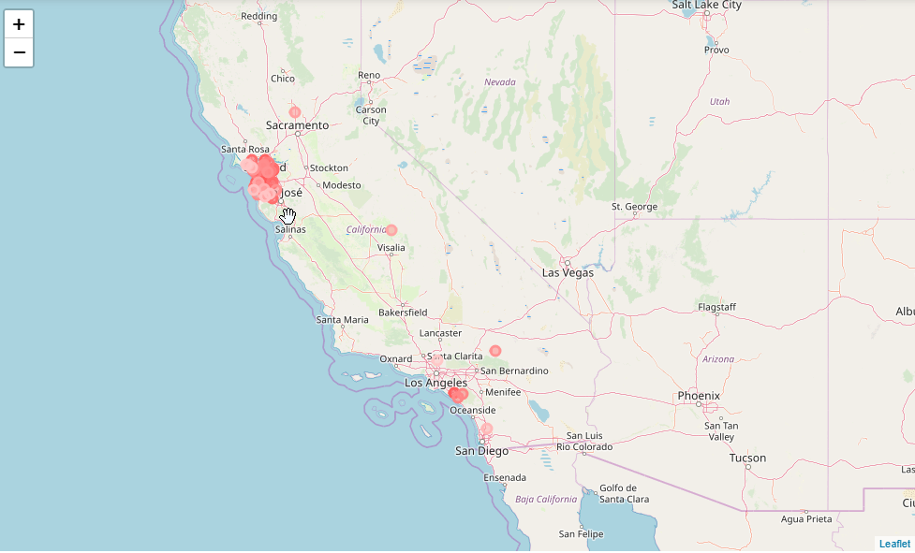

* Figure 1: shows the bulk of the dating profiles reside in California, Bay Area.

**Table of Contents**

1. a statement of your question (or questions!) and how you arrived there
2. the explanation of at least two new columns you created and how you did it
3. the comparison between two classification approaches, including a qualitative discussion of simplicity, time to run the model, and accuracy, precision, and/or recall
4. the comparison between two regression approaches, including a qualitative discussion of * simplicity, time to run the model, and accuracy, precision, and/or recall
5. an overall conclusion, with a preliminary answer to your initial question(s), next steps, and what other data you would like to have in order to better answer your question(s)